**VATTENIVA GESTIONE**

Water Management

Submitted to

K. Srinivas Reddy

CEO Ideabytes

Submitted by:

Alisha Patra

Atish Prakash Singh

G. Margali

Harshita Pandey

Siona Rath

Sai Srujan Siripuram

**CONTENTS:**

1. Project overview
2. Abstract
3. Project description
4. Team contribution
5. Conclusion
6. References

**PROJECT OVERVIEW:**

Monitoring and controlling the height and temperature of water in an overhead tank using IoT.

**ABSTRACT:**

Water is one of the most precious resource since it is the basic need of each and every individual. Since the last few decades the scarcity of water has been a major issue. And the one of the causes of this problem is the overflowing of tanks. So, the project focuses on screening the level of water in the overhead tank.

**PROJECT DESCRIPTION:**

HARDWARE CONTROL UNIT:

* NodeMCU
* Bread board
* Jumper wires
* Ultrasonic sensors
* USB cable

SOFTWARE CONTROL UNIT

* Blynk app
* Blynk library
* Arduino IDE
* Android phone

To prevent the overflowing of water we used sensors in the overhead tank to detect the level of water.

The ultrasonic sensor was connected to the NodeMCU using jumper wires on a breadboard. NodeMCU was used because it has in-built Wi-Fi module, this makes it easy to access the server. We analyzed an already existing code and modified it according to our requirements for detection of water levels in the tank. Then we used Blynk software for creating an app to connect it to the hardware via local host. Once the hardware and the software were connected to the same host, the code was uploaded to the NodeMCU using Arduino IDE for fetching the readings from the sensor. Once the code was uploaded the serial monitor displayed the readings of the depth, level and quantity of water that was exactly equal to the values displayed on the app.

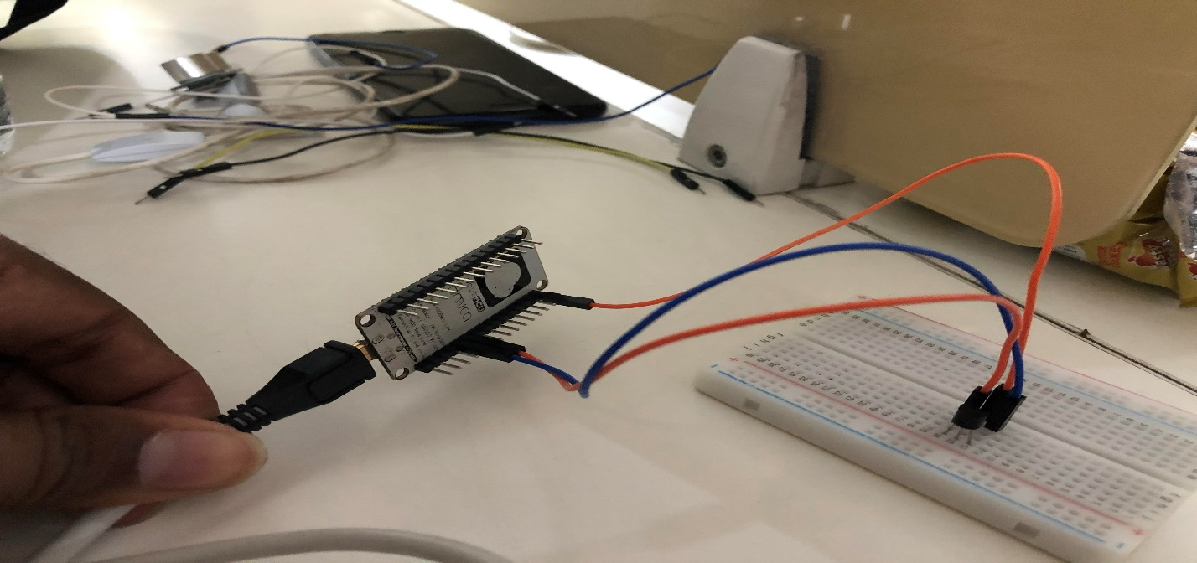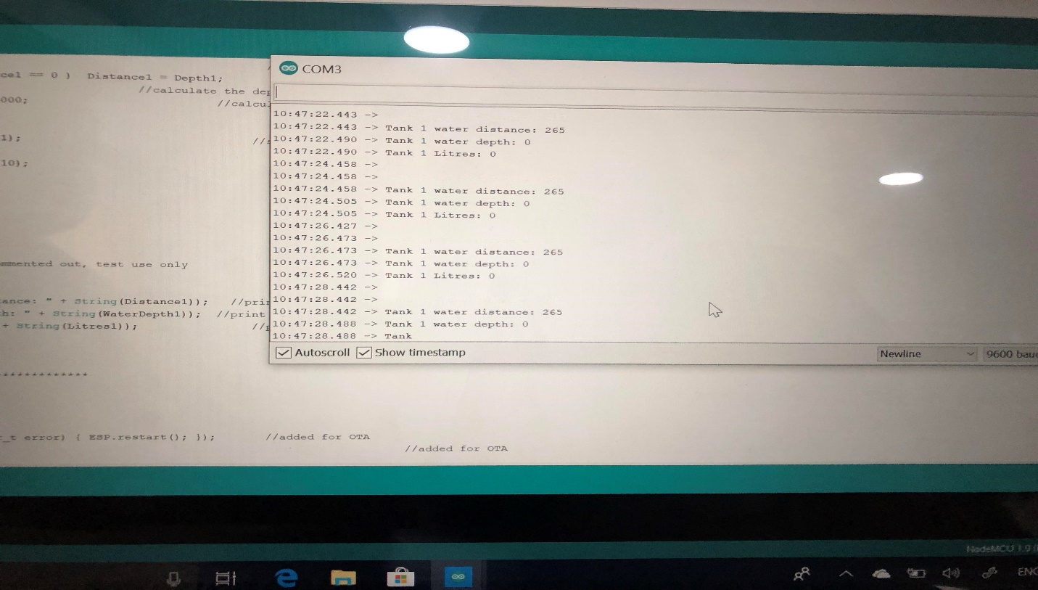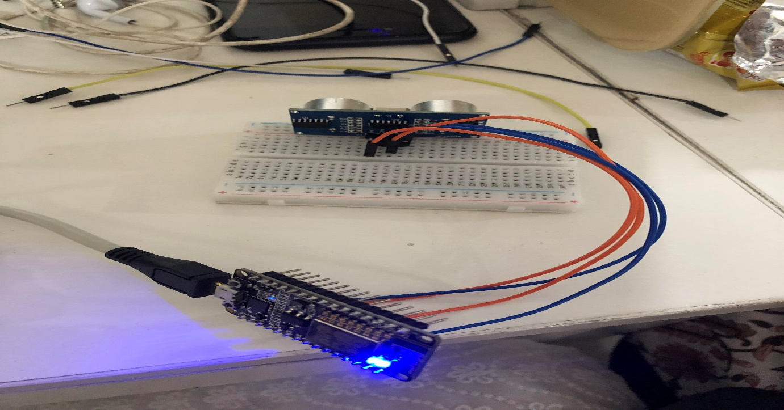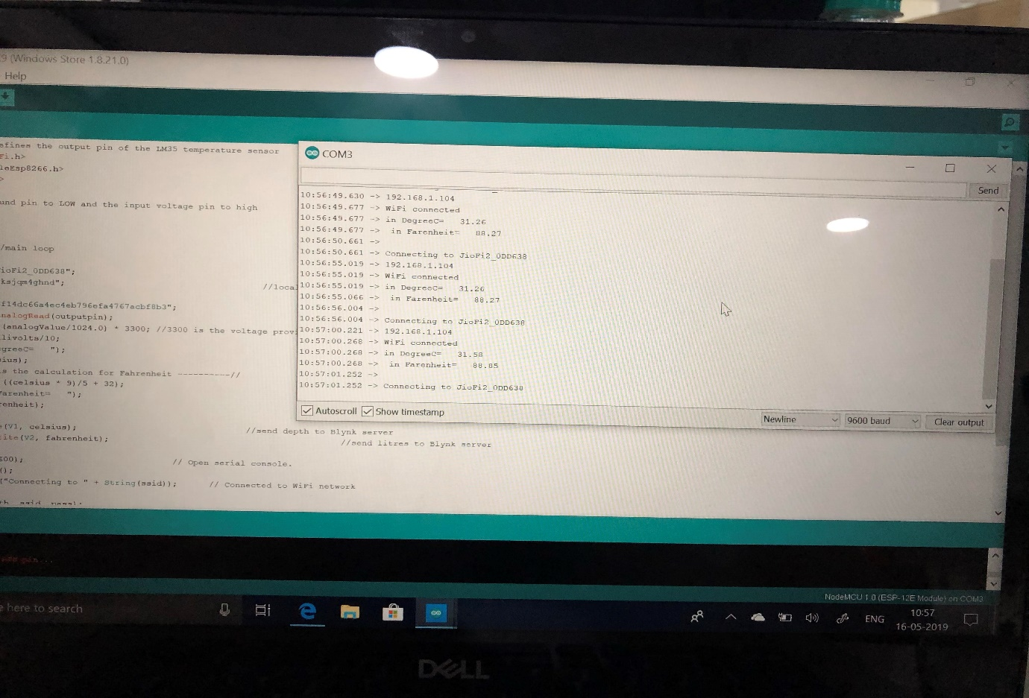

**TEAM CONTRIBUTION:**

Coding and circuit analysis: Margali and Srujan

Circuit building: Atish

Research and implementation: Harshita

Analysis and Blynk app development: Alisha and Siona

**CONCLUSION:**

We attempted to track and control the level of water in the overhead tank. Our goal was to reduce the wastage of water due to overflowing of water. We’ve used ultrasonic sensors and NodeMCU which cuts the cost to an affordable range and makes this project economical and environment-friendly at the same time. This project is also portable and doesn’t require any exclusive tank, it works on the regular present-day tanks.

**REFERENCES:**

1. henrysbench.capnfatz.com/henrys-bench/arduino-projects-tips-and-more
2. [www.instructables.com/id/watertanklevels](http://www.instructables.com/id/watertanklevels)
3. Blynk.io
4. Getting started with internet of things-REES52